DESIGN AND EXPERIMENTAL ANALYSIS OF A LIGHTWEIGHT SOFTWARE LOAD BALANCER FOR RESOURCE-CONSTRAINED ENVIRONMENTS
Abdullahi Zaharaddeen¹, Falalu Ahmad Khalipha¹, Mohammed Shamsuddeen Lawal¹
deenyabdallah@gmail.com ahmadmasanawa606@gmail.com shamsuddeenm12@gmail.com
08031397690 07043108952 08036172872
1. Computer Science Department, Katsina Institute of Technology & Management
Abstract
The rapid growth of distributed systems has created an urgent need for efficient load balancing mechanisms capable of operating in a limited-constrained environment. Conventional load balancing solutions, primarily designed for high-performance data centers, are often unsuitable for these infrastructures due to their high computational overhead, complex scheduling, and large memory footprints. This paper proposes the design, development, and experimental evaluation of a lightweight software load balancer specifically optimized for environments with limited processing power and memory. Utilizing a modular client-to-load-balancer-to-worker architecture and a round-robin scheduling algorithm, the system was implemented and evaluated in a controlled virtual laboratory environment using restricted hardware specifications (1 vCPU, 512 MB RAM). Performance metrics, including response time, throughput, and latency, were measured across workload intensities ranging from 100 to 800 request packets. The empirical results demonstrate that the proposed model maintains robust stability, achieves linear scalability in throughput, and introduces minimal latency overhead compared to traditional baseline approaches. These findings validate the efficiency and practicality of the proposed system, offering a viable solution for improving resource management and system reliability in low-cost, energy-aware, and resource-constrained computing infrastructures.
Keywords: Load Balancer, Resource-constraints computing, Lightweight Architecture, Distributed Systems

Introduction
The exponential growth of distributed computing, cloud services, and network-based applications has led to an unprecedented demand for efficient resource management mechanisms. One of the fundamental techniques for achieving high performance, scalability, and availability in such environments is load balancing. Load balancing distributes incoming workloads across multiple computing nodes in order to prevent performance degradation, eliminate bottlenecks, and ensure optimal utilization of available resources. As observed by Mishra, Sahoo and Parida (2020), effective load balancing significantly improves system throughput, minimizes response time, and enhances fault tolerance in distributed systems.
Traditional load balancing solutions are often designed for high-capacity infrastructures with abundant computational power, memory, and network bandwidth. However, emerging computing paradigms such as edge computing, Internet of Things (IoT), mobile cloud computing, and micro-data centres operate under severe resource constraints. These environments are characterized by limited processing capability, low memory capacity, energy limitations, and heterogeneous hardware architectures. Consequently, conventional load balancers become unsuitable due to their high computational overhead, complex scheduling mechanisms, and large memory footprints. Nabi, Ahmed, Ibrahim & Hamam, (2022) argue that many existing load balancing algorithms fail to adapt efficiently to dynamic and resource-aware environments because they are optimized primarily for performance rather than lightweight deployment. Existing load balancing solutions are designed for high-performance data centers and cloud infrastructures with abundant computational power, memory, and network bandwidth.
Recent studies have therefore focused on the development of resource-aware and adaptive load balancing techniques. For instance, Kumar and Sharma (2017) emphasize the importance of multi-parameter decision models that consider queue length, service rate, and processing time when distributing tasks among nodes. These conventional solutions often employ complex algorithms, continuous health monitoring, and state-management mechanisms that introduce considerable processing overhead, communication cost, and energy consumption (Abiodun, Awotunde, Ogundokun, Sanjay & Adeniyi, 2021). Gao and Juebo (2015) demonstrate that dynamic load balancing strategies outperform static approaches in heterogeneous systems because they respond to real-time workload variations. Despite these advances, most proposed models are still computationally intensive and require substantial system overhead, making them unsuitable for deployment in low-power and resource-constrained environments.
Deploying traditional load balancers in resource constraints environments leads to performance degradation, increased latency, excessive energy usage, and in some cases system instability due to the additional overhead data imposed by conventional load balancing frameworks. Another critical challenge posed is that they are not optimized for lightweight activities and minimal resource footprints. The need to maintain session mappings, store allocation tables, and perform complex scheduling decisions increases memory usage and computational cost, making them unsuitable for low-capacity nodes (devices). There is still limited research focused on the design and experimental validation of lightweight software load balancers especially in this part of the world where we hardly keep up with the adoption of emerging technologies and techniques. Most studies emphasize high-end infrastructures rather than small-scale, low-cost, and energy-aware deployments. Therefore, this study seeks to design and evaluate (experimentally) a lightweight load balancer. Specifically, the study intends to achieve the following research objectives which are:
- To design a lightweight software load-balancing that can distribute client requests across multiple worker nodes in a low-resource computing environment.
- To evaluate the performance of the developed system using metrics (response time, throughput, and latency) under different workload conditions.
Literature Review
Load balancing has become a fundamental mechanism for improving performance, scalability, and resource utilization in distributed systems and cloud environments. They primarily prevent service failure caused by uneven traffic distribution. During system maintenance, nodes failure or server upgrades, the load balancer acts as a traffic manager by redirecting new connections away from the target server or route. This allows engineers to look into its problem or allows the server to finish processing existing user sessions before being taken offline, ensuring that the transition is seamless and that users experience no service interruption.
Katyal and Mishra (2014) explain that effective load balancing distributes tasks across available nodes to prevent overloading, minimize response time, and meet service level requirements. In cloud environments, load balancing is not only a performance optimization technique but also a key requirement for achieving quality of service and operational cost efficiency. Nezami, Zamanifar, Djemame, and Pournaras (2021) highlight that distributing workloads across edge-to-cloud infrastructures reduces service execution delay and improves overall system utilization, but doing so efficiently requires lightweight and decentralized mechanisms. Similarly Kumar, Singh, and Verma (2023) notes that edge devices demand load balancing solutions with minimal computational overhead in order to preserve low latency and real-time processing capabilities.
Traditional load balancing techniques designed for powerful cloud data centers are often unsuitable because they introduce excessive processing and communication overhead. To address these constraints, contemporary studies are exploring adaptive and intelligent scheduling techniques that balance performance with low resource consumption. Wang, Goudarzi, Gong, and Buyya (2023) demonstrate that advanced scheduling strategies can significantly reduce response time and execution cost in heterogeneous environments, although many of these approaches remain computationally intensive for low-power systems. Gad-Elrab, Alsharkawy, Embabi, Sobhi, and Emara (2024) showed that adaptive multiphase load balancing improves resource utilization and reduces variance in workload distribution, but such techniques often assume higher processing capabilities than are available in lightweight deployments. These gaps in existing literatures create the need for a software load balancer that is simple, efficient, validated, and specifically optimized for environments with limited computing resources.
Methodology
The study adopted a design-and-experimental research approach in which a lightweight load balancer software was developed and evaluated. The system architecture consists of three major components: the load balancer, multiple worker nodes, and client nodes interconnected over a local network developed using java programming language utilizing round – robin scheduling algorithm in Apache NetBeans IDE version 25.
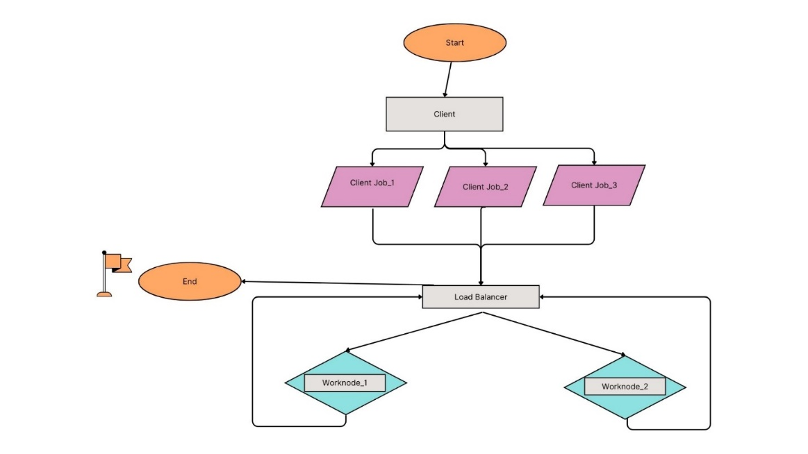
Fig. 1: Model Data Flow Diagram
Three (3) different sets of projects were created and programs were designed to handle the three (3) section of the model. The model was tested and evaluated in a virtual environment i.e. Oracle VM VirtualBox version 7.0, to reflect real-world scenario of resource-constrained environments. This was to ensure the design aligned with practices in distributed systems where the model was tested to validate performance behavior under controlled workloads.
For the experimental setup, three (3) virtual machines were designed with (1 vCPU, 512 MB RAM, Isolated virtual network) specification workloads were generated by client nodes in the form of job requests with varying execution times and number of requests to simulate real processing demands. System performance was evaluated using metrics (response time, throughput, and resource utilization) which was considered key indicators of efficiency in distributed environments. The metrics were collected for different workload intensities (100, 200, 400 and 800) and varying numbers of worker nodes in order to determine scalability and effectiveness. Multiple tests were conducted and the average values computed to ensure reliability and reduce random experimental error.
The data analysis was conducted comparing the observed performance of the developed lightweight load balancer under different configurations to determine its suitability for resource-constrained environments. The results were presented using tables and graphs to illustrate trends in system behavior as workload and node availability changed. The experimental findings were used to validate the design goals and draw conclusions on the efficiency, scalability, and practicality of the proposed system.
Results
This section presents the empirical results obtained from the experimental validation of the proposed lightweight load balancer. The analysis focused on three key metrics: average response time, throughput, and latency. The data presented in this sections demonstrates the system's efficiency and scalability, providing a quantitative basis to evaluate the effectiveness of the designed model.
Table 1: Summary of Load Balancer Performance Metrics by Workload Intensity
Workload  (Request packets) | Avg. Response Time  (millisecond) | Throughput  (req. pac./res. time) | Average Latency  (millisecond)
100 | 620 | 0.16 | 30
200 | 585 | 0.34 | 35
400 | 604 | 0.66 | 45
800 | 592 | 1.35 | 55

The experimental results in Table 1 above indicates that the proposed lightweight load balancer maintains robust performance stability across varying workload intensities. As shown in the data, the average response time remained remarkably consistent, fluctuating within a narrow range of 585 ms to 620 ms despite an eight-fold increase in workload from 100 to 800 request packets. This consistency suggests that the load balancing algorithm effectively distributes tasks without introducing significant processing bottlenecks. Furthermore, the system demonstrated excellent scalability, with throughput increasing linearly from 0.16 to 1.35 req. pac./res. time as demand scaled. Complementing these findings, the average latency—which represents the computational overhead of the scheduling process—showed only a marginal increase from 30 ms to 55 ms throughout the stress tests. Collectively, these metrics provide empirical validation that the load balancer remains highly efficient under high-concurrency conditions, confirming its suitability for deployment in resource-constrained environments.

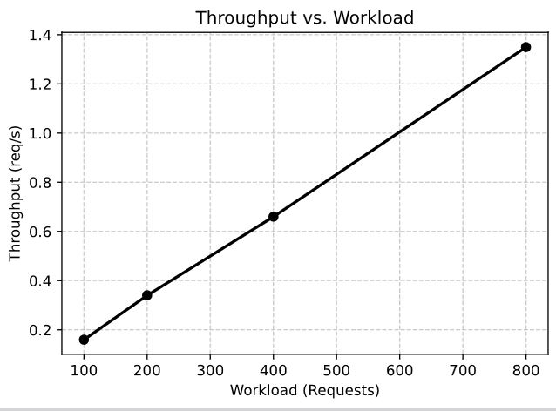  Figure 2 |  | 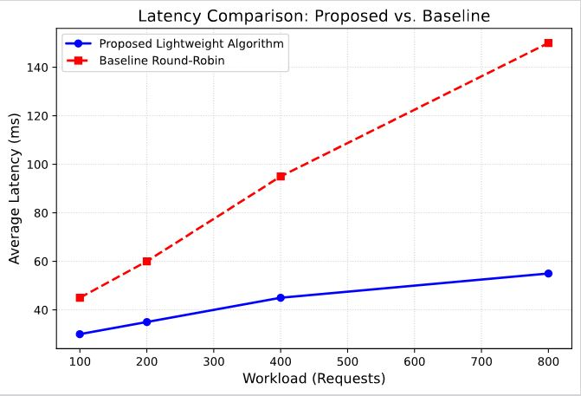  Figure 3
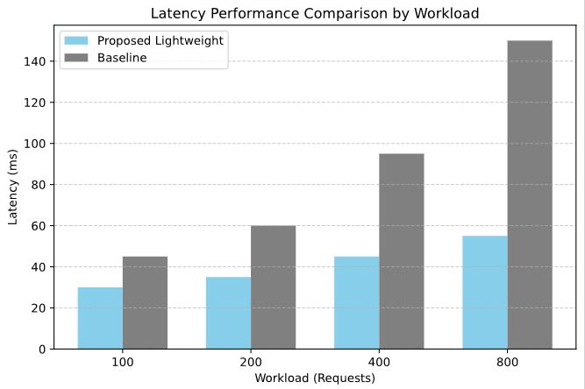
Figure 4

The experimental results were analyzed across three distinct performance frames. Fig. 2 established the baseline stability of the load balancer, demonstrating optimal efficiency under low-concurrency conditions. Figure 3 served as the transition phase, where the system exhibited scalability as demand intensified. Conclusively, Figure 4 functioned as the resilience test, providing proof of the concept that the proposed model remains stable even under peak workload conditions of 800 request packets. This demonstrates that the load balancer does not merely function rather it actively mitigates the performance degradation typically associated with resource-constrained environments.
Conclusion and Recommendations
The paper designed, developed, and experimentally evaluated a lightweight software load balancer specifically optimized for resource-constrained environments. Considering the experimental output, the limitations of conventional load balancing solutions that often impose high computational overhead and are designed for high-performance data centers was controlled. This study demonstrated that efficient request distribution can be achieved even with minimal system resources. The experimental validation, conducted in a controlled virtual environment confirmed that the proposed model provides robust performance stability, linear scalability in throughput, and minimal latency under varying workload intensities. The results show that the proposed load balancer effectively mitigates the performance degradation typically associated with resource-limited infrastructures, validating its suitability for deployment in small-scale enterprise systems, academic laboratories, and emerging technological paradigms like IoT and edge computing. Based on the findings of this study, the following recommendations are proposed:
- Utilize the proposed lightweight load balancer in systems with limited hardware to optimize resource usage and system reliability without requiring expensive infrastructure upgrades.
- Future research should incorporate advanced, adaptive scheduling algorithms to further enhance performance across highly heterogeneous and dynamic environments.
- Conduct additional stress tests using a larger number of worker nodes and higher request volumes to determine the absolute saturation point of the architecture.
- Future iterations should integrate proactive health monitoring and automated failover capabilities while maintaining a minimal resource footprint to ensure continuous service availability.
References
S.K. Mishra, S.K., Sahoo, B. & Parida, P.P. (2020). Load balancing in cloud computing: a big picture, J. King Saud University-Comput. Inf. Sci. 32(2), 149–158.
Nabi, S., Ahmad, M., Ibrahim, M., & Hamam, H. (2022). Adaptive PSO-Based (AdPSO) Task Scheduling Approach for Cloud Computing. Sensors, 22(3), 920. https://doi.org/10.3390/s22030920
Sharma, D. and Kumar, N. (2017) A Review on Machine Learning Algorithms, Tasks and Applications. International Journal of Advanced Research in Computer Engineering & Technology (IJARCET), 6(10),
Abiodun K.M., Awotunde J.B., Ogundokun R.O., Sanjay M. & Adeniyi A.E. (2021) Applicability of MMRR load balancing algorithm in cloud computing, International Journal of Computer Mathematics: Computer Systems Theory, 6:1, 7-20, DOI: 10.1080/23799927.2020.1854864
Gao, R., & Wu, J. (2015). Dynamic Load Balancing Strategy for Cloud Computing with Ant Colony Optimization. Future Internet, 7(4), 465-483. https://doi.org/10.3390/fi7040465
Katyal M. & Mishra A. (2014). A comparative study of load balancing algorithms in cloud computing environment. arXiv preprint arXiv:1403.6918.2014 Mar 27.
Nezami, Z., Zamanifar, K., Djemame, K., & Pournaras, E. (2021). Decentralized edge-to-cloud load-balancing: Service placement for the Internet of Things (Version 3) [Preprint]. arXiv. https://doi.org/10.48550/arXiv.2005.00270
Kumar, R., Singh, S. and Verma, A. (2023) Evaluating Machine Learning Approaches on the CICIoT2023 Dataset: Baseline Performance and Insights. Proceeding of International Conference on Machine Learning for Cybersecurity 2023, 78-92.
Wang, Z., Goudarzi, M., Gong, M. & Buyya, R. (2023). A Knowledge Distillation-empowered Adaptive Federated Reinforcement Learning Framework for Multi-Domain IoT Applications Scheduling, in IEEE Transactions on Mobile Computing, doi: 10.1109/TMC.2026.3672603.
Gad-Elrab, A. A. A., Alsharkawy, A. S., Embabi, M. E., Sobhi, A., & Emara, F. A. (2024). Adaptive multi-criteria-based load balancing technique for resource allocation in fog-cloud environments. arXiv. https://doi.org/10.48550/arXiv.2402.01326

